‘GN Type’ Shunting Locomotive
Henry Greenly, Feb 1910
The first, and so far, the only 3D Printed model locomotive in Gauge 2 (2” Gauge, 7/16” / ft Scale)
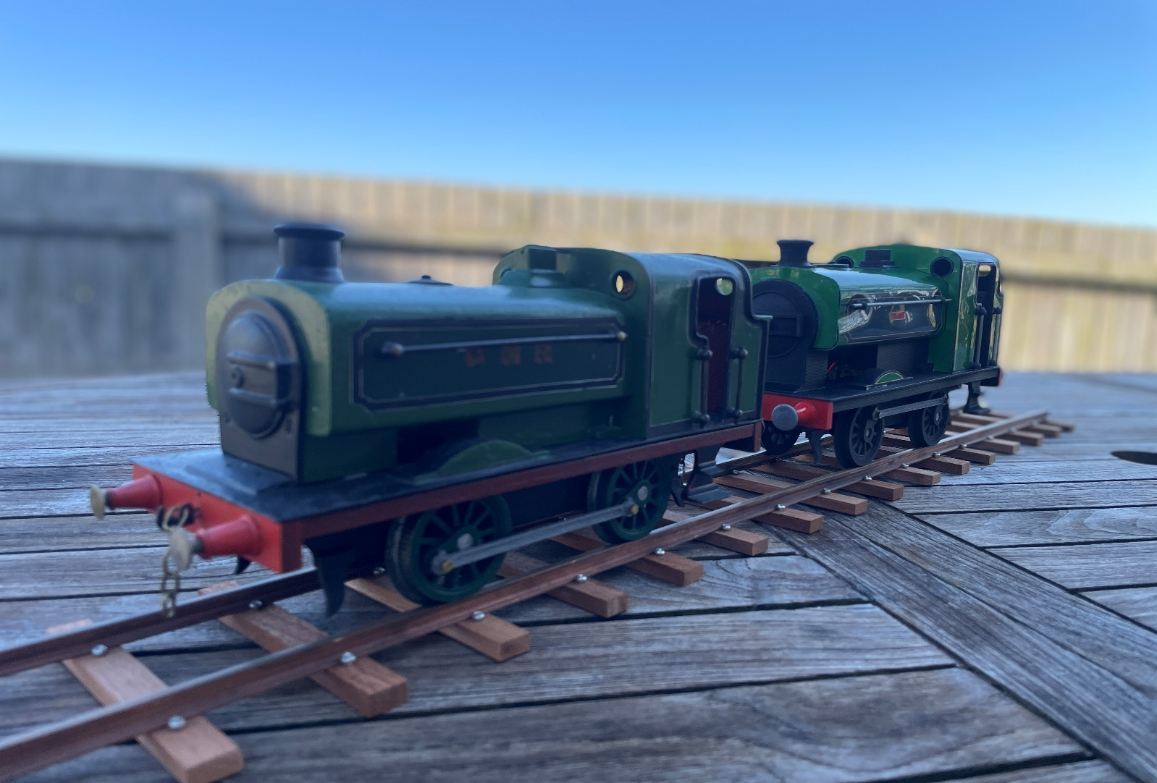
Original (Bassett-Lowke, c. 1910) and 3D printed version (DV, 2023) together for the first time, April, 2023.

